Lab 4 — ServiceNow ITSM
Personal Developer Instance (Free) · No Credit Card · Network+ · ITIL

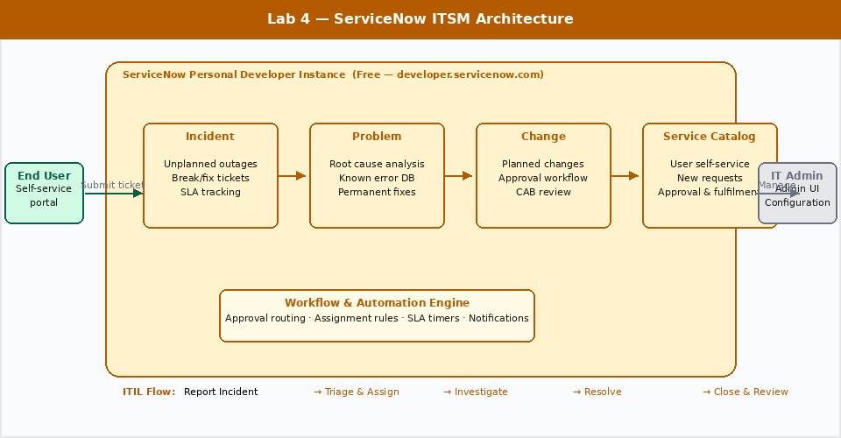

Field | Value
Certification alignment | CompTIA A+ · Network+ · ITIL 4 Foundation
Free tools | ServiceNow Personal Developer Instance — free at developer.servicenow.com, no credit card, no expiration
Time to complete | 2–3 hours across multiple sessions
Estimated cost | $0 — ServiceNow PDI is permanently free
Career relevance | IT Support · Help Desk · Sysadmin · ITSM Platform Administrator

The Business Problem This Lab Solves

When users report IT problems, those problems need to be tracked, routed, prioritised, assigned, worked, and resolved — consistently and auditably. Without a structured system, things fall through the cracks. A server goes down, three people report it to three different team members, nobody knows which one is working on it, and it takes four hours to fix something that should have taken one.

ServiceNow is how most enterprise IT organisations solve this. It is an IT Service Management platform — a structured system for handling every type of IT request, from a password reset to a major infrastructure outage. It enforces process: incidents follow an incident workflow, change requests require approval, service requests come from a catalogue with predefined fulfilment steps.

ServiceNow is one of the most widely deployed enterprise software platforms in the world. If you are going into IT support, you will use it or something that works exactly like it from your first week on the job. Having hands-on experience with it before you start is a meaningful differentiator.

Role | How this lab applies
IT Support / Help Desk | Creating and resolving incidents is the core daily task of every help desk role
Sysadmin | Change management — logging, approving, and documenting infrastructure changes
IT Service Manager | Building service catalogues, defining workflows, reporting on SLA compliance
Cloud Engineer | Cloud operations teams use ServiceNow for change requests, incident management, and service requests for cloud resources

What You Will Learn

Skill | Real-world application
Create and resolve an Incident | The most common task in every IT support role — done from day one
Set ticket priority and SLA | Priority determines response time. SLAs define the commitment to the business. You need to understand both to work in a professional IT environment
Assign tickets to queues and individuals | Routing is critical in a team environment — the wrong person working a ticket wastes time and delays resolution
Build a service catalogue item | Service catalogues let users self-serve common requests (new laptop, software access, password reset) without calling the help desk for every ticket
Create a workflow for approvals | Change requests and access requests require manager approval before fulfilment — workflows automate this
Run reports on ticket volume and resolution time | Metrics drive IT operations decisions. Knowing how to pull and interpret reports is expected at every level
Understand ITIL incident vs problem vs change | The three core ITIL process types — every enterprise IT role uses this language

Step 1 — Get Your Free Instance

- Go to developer.servicenow.com
- Click Sign Up and create a free account — email and password only, no credit card
- Once logged in, click Request Instance
- Select the latest stable release (Washington or newer)
- Click Request — your instance provisions in 10–15 minutes
- You will receive an email with your instance URL (format: dev12345.service-now.com) and login credentials

Keep your instance active. ServiceNow hibernates Personal Developer Instances that haven't been accessed in 10 days and reclaims instances inactive for more than 30 days. Log in at least once a week to keep it active. If it gets reclaimed, you can request a new one for free — but you lose your work.

Step 2 — Navigate the Platform

When you first log in, you are in the ServiceNow admin interface. The left navigation panel gives you access to all modules. The key areas for this lab:

Module | Where it is | What it does
Incident | Service Desk → Incidents | The primary module for IT support tickets
Problem | Service Desk → Problems | Root cause analysis for recurring incidents
Change | Change → Changes | Planned modifications to IT infrastructure
Service Catalog | Service Catalog → Catalogs | The user-facing request portal
Reports | Reports → Create New | Analytics and metrics
Workflow Editor | Process Automation → Flow Designer | Visual workflow builder

Step 3 — Create and Work an Incident

Create the Incident

- Navigate to Service Desk → Incidents → New
- Fill in the form with this scenario:

Field | Value
Caller | Search for and select a user from the directory — use Abel Tuter as a test user
Category | Software
Subcategory | Email
Short description | User cannot access Outlook — error: Cannot connect to server
Description | User reports that Outlook stopped working this morning at approximately 9am. Error message: 'Cannot connect to the Exchange server. Verify your network settings.' Other users in the same building are not affected. User is on a laptop, connected via Wi-Fi.
Priority | 3 — Moderate (one user affected, workaround available — use webmail)
Assignment Group | Service Desk

- Click Submit
- Note the ticket number (format: INC0001234) — this is the tracking ID

Work the Incident

- Open the incident you just created
- Change the State to In Progress
- Assign it to yourself — click the Assigned to field and search your username
- Add a Work Note (visible to IT staff only):

Work Note: Contacted user. Confirmed error message. Outlook profile appears corrupted.
Attempting profile repair. Instructed user to use OWA (webmail) in the interim.
Resolution ETA: 30 minutes.

- Add a resolution in the Resolution Notes field:

Resolution: Rebuilt Outlook profile. Removed and re-added the Exchange account.
User confirmed Outlook is working. Issue was a corrupted OST file.
Closed with user confirmation.

- Change State to Resolved → Closed

Step 4 — Build a Service Catalogue Item

Service catalogue items let users request common IT services through a self-service portal without calling the help desk. This reduces ticket volume for routine requests and speeds up fulfilment.

Create a New Laptop Request Item

- Navigate to Service Catalog → Catalogs → Service Catalog
- Click Maintain Items → New
- Fill in:

Field | Value
Name | New Laptop Request
Category | Hardware
Short description | Request a new or replacement laptop
Description | Use this form to request a new laptop for a new hire or to replace a failed or end-of-life device. Requests are reviewed within 2 business days. Delivery takes 5–7 business days after approval.
Fulfillment group | IT Hardware Team
Price | Leave blank — internal requests do not have a user-facing cost

- Click Submit to save the catalogue item
- Click the Variables tab and add these fields:

Variable Name | Type | Mandatory
Requester Name | Single Line Text | Yes
Business Justification | Multi Line Text | Yes
Required By Date | Date | Yes
Laptop Model Preference | Select Box (Options: Standard, Developer, Executive) | No

- Save and Preview the item — it now appears in the service catalogue portal

Step 5 — Create an Approval Workflow

Change requests require manager approval before work begins. This is a core ITIL control — changes to production infrastructure need authorisation to prevent uncoordinated modifications that could cause outages.

- Navigate to Change → Changes → New (Standard)
- Fill in a sample change request:

Field | Value
Short description | Deploy security patch MS24-001 to all Windows workstations
Category | Software
Risk | Low
Impact | 2 — Medium
Start date | Next Saturday at 2:00 AM
End date | Next Saturday at 6:00 AM
Description | Monthly security patch deployment. Patch addresses CVE-2024-0001 rated CVSS 7.8. Workstations will require one reboot. Deployed via WSUS. Rollback plan: uninstall via WSUS if issues reported post-deployment.

- Under the Planning tab, add a Test Plan and Backout Plan
- Click Request Approval — this moves the change to Pending Approval state
- Navigate back to the change and find the Approvals tab — approve it as the admin user
- The change moves to Scheduled state

Step 6 — Build a Report

- Navigate to Reports → Create New
- Name: Incident Volume by Priority — Last 30 Days
- Data: Incident [incident]
- Type: Bar Chart
- Group by: Priority
- Add a condition: Created is on or after 30 days ago
- Click Save and Run

Build two more reports for your portfolio:

- Mean Time to Resolution (MTTR) — bar chart grouped by Assignment Group
- Open Incidents by Assigned Agent — useful for workload balancing

ITIL Concepts to Know

These terms come up in every IT support interview and are tested in ITIL Foundation. Understanding how they map to ServiceNow makes them concrete.

ITIL Term | Definition | ServiceNow Module
Incident | An unplanned interruption to a service. Goal: restore service as quickly as possible. | Service Desk → Incidents
Problem | The root cause of one or more incidents. Goal: eliminate the root cause permanently. | Service Desk → Problems
Change | A planned modification to infrastructure or applications. Goal: implement with minimal risk. | Change → Changes
Service Request | A user request for something new (access, hardware, information). Not a break/fix. | Service Catalog
SLA | Service Level Agreement — the committed response and resolution time for each priority level. | SLA → SLA Definitions
CMDB | Configuration Management Database — the record of every IT asset and its relationships. | Configuration → CIs
Knowledge Base | Articles documenting known issues and their solutions — reduces repeat incident volume. | Knowledge → Articles

Portfolio entry for this lab. Take screenshots of: a completed incident with work notes and resolution, your service catalogue item, the approval workflow on a change request, and one dashboard report. Write a paragraph for each explaining what process it supports and why it matters in an IT environment.

